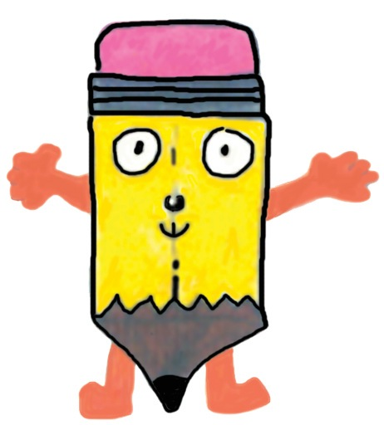
Skribblers Magazine Inc. Permission Form

Publication requires parent/guardian consent.
Completion of this form acknowledges that the work submitted is original and the work and property of the author listed.

Permission to Print
I give permission for Skribblers Magazine Inc. to publish:

__________________________________________________ By __________________________________________
(Title) (Author/Artist)

Age:______________ School: ___________________________________________________________________

I also do/ do not (circle one,) give permission for future use of this piece on Skribblers website. (Permission for use on the magazine website is not required for your child’s piece to be included in the upcoming print version of Skribblers.)

__________________________________________________________________ Date_________________________
(Signature of parent/guardian)

Address (for correspondence):

_________________________________________________________________________________________________
(Street and Number)

_________________________________________________________________________________________________
(City and State) (Zip code)
(School address may be used)

Please print, sign, and mail or email this form to:
Skribblers Magazine Inc.
P.O. Box 286
Clifton Park, N.Y. 12065 or email: Skribblerssubmissions@gmail.com
Try writing 5 minutes per day everyday for a week. Free your voice

